A one-way ANOVA is often described as an omnibus test because whilst it informs you whether there are any differences between the means of three or more groups, it does not inform you which group(s) differ from the others.

H0: all group means are equal (i.e., µ1 = µ2 = µ3 = ... = µk). There are no mean differences between GROUP1/GROUP2/GROUP3… on the dependent variable.

H1: at least one group mean is different (i.e., they are not all the same). There are mean differences between GROUP1/GROUP2/GROUP3… on the dependent variable.

## Planned contrasts and post-hoc tests

To know which group mean(s) differ from other group mean(s), you can run either planned contrasts (usually abbreviated to just "contrasts") or post-hoc tests. Contrasts are specific group comparisons you want to make and are decided before you analyze the data (i.e., a priori tests). Alternatively, post-hoc tests are for when you have no specific hypotheses about any particular group mean comparison(s). They test all possible group comparisons and are the most common approach to discovering differences between the groups.

To investigate which groups differ, you can use post-hoc tests, of which many are available in SPSS. The options available in this guide will focus on post-hoc tests that examine all possible group combinations. The total number of possible comparisons that you will have will depend on how many groups you have in your independent variable. However, the total possible number of comparisons can be calculated using the following formula:

Number of comparisons = k (k – 1) / 2

where k = number of groups. So, for three groups there will be 3(3 – 1) / 2 = 3 possible comparisons and for four groups (as in this example) there will be six possible comparisons as 4(4 – 1) / 2 = 6.

When you have homogeneity of variances, a commonly used and generally good post-hoc test is the Tukey post-hoc test (also called the Tukey HSD test). When you do not, the Games-Howell post-hoc test is more appropriate.

## Effect sizes

The one-way ANOVA, as a null hypothesis significance test, informs you whether the differences between group means are 'real', but it does not inform you of the 'size' of the difference. To try to overcome this limitation, an effect size can be calculated. There can be many different types of effect size, with different types often trying to 'capture' the importance of your results in different ways. Effect sizes have their limitations but, nonetheless, they are becoming an important part of reporting your results and, as such, you will be shown how to calculate an effect size called ω2 (omega squared) for the one-way ANOVA.

**Sample size and (un)balanced designs**

Generally, your study should have six or more participants in each group in order to proceed with a one-way ANOVA, but ideally you would have more. A one-way ANOVA will run with less than six participants, but your ability to infer to a larger population will be more difficult.

If you have an equal numbers of cases (e.g., participants) in each group, you have what is called a 'balanced' design. On the other hand, if sample sizes are not the same in all groups, you have an 'unbalanced' design. Generally speaking, the more unbalanced the design, the greater the negative effect of any violation of assumptions on the validity of the test. Ideally, you want a balanced design (although this can be hard to achieve in practice).

## What problems can you solve using a one-way ANOVA?

A one-way ANOVA is most often used for three types of study design:

### 1. Determine if there are differences between three or more independent groups

You have a study design where you are measuring the same dependent variable in three or more independent (i.e., unrelated) groups (and you want to know if there are differences between groups), a one-way ANOVA might be appropriate. For example, you could use a one-way ANOVA to compare maximal aerobic capacity in swimmers, runners and cyclists. Another example could be to investigate any differences in blood cholesterol concentration in sedentary, low, moderate and high physical activity groups.

### 2. Determine if there are differences between conditions (with no pre-test measurement taken)

If you have a study design where three or more independent groups have performed different interventions (e.g., control/interventions) and the same dependent variable is measured at the end of the study in all groups, a one-way ANOVA might be appropriate. For example, one group acted as a control, one group underwent an exercise-training program and another group underwent a dietary program. Body weight was measured at the end of each program and compared between the three separate groups to determine if there were any statistically significant mean differences between the groups.

### 3. Determine if there are differences in change scores

If you have a study design where three or more independent groups have performed different interventions (e.g., control/interventions), the same dependent variable is measured at the beginning and end of the study in all groups, and a change score calculated (i.e., post-values minus pre-values), a one-way ANOVA might be appropriate. For example, pre- and post- blood glucose concentration measurements were taken and change scores calculated for an exercise intervention group, dietary intervention and a control group. These change scores were then compared between the three groups using a one-way ANOVA. This will determine whether the changes in blood glucose concentration between groups were equal or if there were statistically significant differences in change score (i.e., the intervention type had a differential effect on change in blood glucose concentration).

**Assumptions**

1. Your **dependent variable** should be measured at the **interval** or **ratio level** (i.e., they are **continuous**). Examples of variables that meet this criterion include revision time (measured in hours), intelligence (measured using IQ score), exam performance (measured from 0 to 100), weight (measured in kg), and so forth.

2. Your **independent variable** should consist of **two or more categorical**, **independent groups**. Typically, a one-way ANOVA is used when you have **three or more** categorical, independent groups, but it can be used for just two groups (but an independent-samples t-test is more commonly used for two groups). Example independent variables that meet this criterion include ethnicity (e.g., 3 groups: Caucasian, African American and Hispanic), physical activity level (e.g., 4 groups: sedentary, low, moderate and high), profession (e.g., 5 groups: surgeon, doctor, nurse, dentist, therapist), and so forth.

3. You should have **independence of observations**, which means that there is no relationship between the observations in each group or between the groups themselves. For example, there must be different participants in each group with no participant being in more than one group. This is more of a study design issue than something you can test for, but it is an important assumption of the one-way ANOVA. If your study fails this assumption, you will need to use another statistical test instead of the one-way ANOVA (e.g., a repeated measures design).

4. There should be **no significant outliers**. Outliers are simply single data points within your data that do not follow the usual pattern (e.g., in a study of 100 students' IQ scores, where the mean score was 108 with only a small variation between students, one student had a score of 156, which is very unusual, and may even put her in the top 1% of IQ scores globally). The problem with outliers is that they can have a negative effect on the one-way ANOVA, reducing the validity of your results. Fortunately, when using SPSS to run a one-way ANOVA on your data, you can easily detect possible outliers.

5. Your **dependent variable** should be **approximately normally distributed for each category of the independent variable**. We talk about the one-way ANOVA only requiring **approximately** normal data because it is quite "robust" to violations of normality, meaning that assumption can be a little violated and still provide valid results. You can test for normality using the Shapiro-Wilk test of normality, which is easily tested for using SPSS.

6. There needs to be **homogeneity of variances**. You can test this assumption in SPSS using Levene's test for homogeneity of variances. If your data fails this assumption, you will need to not only carry out a Welch ANOVA instead of a one-way ANOVA, which you can do using SPSS, but also use a different post-hoc test.

These assumptions need to be tested before you can run a one-way ANOVA. Fortunately, the one-way ANOVA is fairly "robust" to violations of normality. "Robust", in this case, means that the assumption can be violated (a little) and still provide valid results. Therefore, you will often hear of this test only requiring approximately normal data and some argue that data can even be fairly skewed as long as the number of cases (e.g., participants) in each group is similar. The preferred order of testing of these assumptions, and the order followed in this guide, is as follows:

1. Detect any outliers.  
2. Determine if data is approximately normally distributed in each group.  
3. Determine if there is homogeneity of variances.

## Example

A researcher believes that individuals that are more physically active are better able to cope with stress in the workplace. To test this theory, the researcher recruited 31 subjects and measured how many minutes of physical activity they performed per week and their ability to cope with workplace stress. The subjects were categorized into four groups based on the number of minutes of physical activity they performed: namely, "sedentary", "low", "moderate" and "high" physical activity groups. These groups (levels of physical activity) formed an independent variable called group. The ability to cope with workplace stress was assessed as the average score of a series of Likert items on a questionnaire, which allowed an overall "coping with workplace stress" score to be calculated; higher scores indicating a greater ability to cope with workplace-related stress. This dependent variable was called stress_coping and "ability to cope with workplace-related stress" abbreviated as "CWWS" score. The researcher would like to know if CWWS score is dependent on physical activity level. In variable terms, is stress_coping different for different levels of group?

To run a one-way ANOVA in SPSS, follow these instructions:

1. Click **Analyze > Compare Means > One-Way ANOVA...** on the top menu, as shown below:

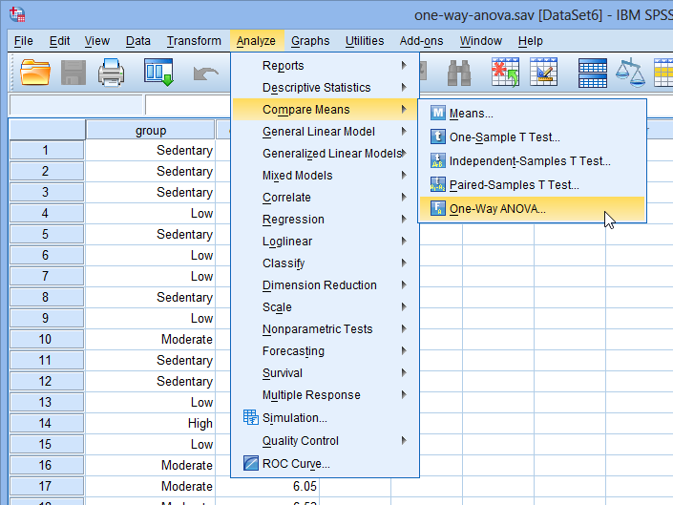

Explanation: The Dependent List: box is where you enter the dependent variable(s) you wish to analyze. You can transfer more than one dependent variable into this box to simultaneously analyze many dependent variables at the same time. The independent variable is referred to as a factor (i.e., a 'between-subjects factor') in SPSS for this procedure. Whenever you transfer a categorical variable – for example group – into the Factor: box, SPSS will automatically use all the groups in this variable in its calculation of the one-way ANOVA. If you do not want this to happen you need to deselect the group(s) you do not want to analyze before running the one-way ANOVA procedure.

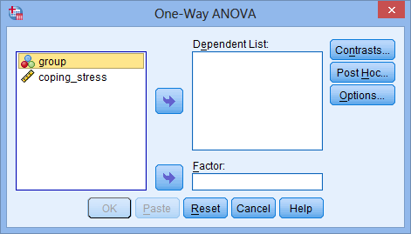You will be presented with the **One-Way ANOVA** dialogue box, as shown below:

2. Transfer the dependent variable, coping_stress, into the Dependent List: box and the independent variable, group, into the Factor: box, using the https://statistics.laerd.com/premium/owa/img/right-arrow-button.png buttons, as shown below:

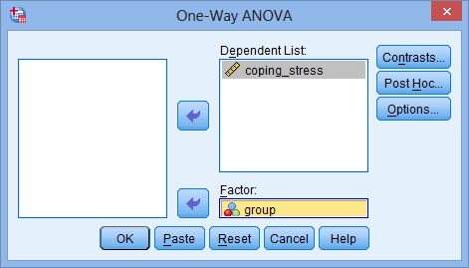

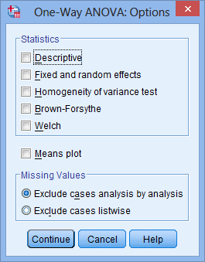3. Click the https://statistics.laerd.com/premium/owa/img/options-button.pngbutton and you will be presented with the **One-Way ANOVA: Options** dialogue box, as shown below:

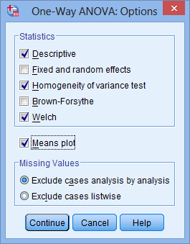

4. Click the Descriptive, Homogeneity of variance test and Welch checkboxes in the –Statistics– area and select

the Means plot checkbox. You should end up with the following screen:

Note: With the exception of the Descriptive option, the options that you have selected above will instruct SPSS to test for homogeneity of variances using Levene's Test for Homogeneity of Variances, and provide a robust ANOVA (Welch's ANOVA) in case the assumption of homogeneity of variances is violated.

5. Click the https://statistics.laerd.com/premium/owa/img/continue-button.pngbutton and you will be returned to the **One-Way ANOVA** dialogue box.

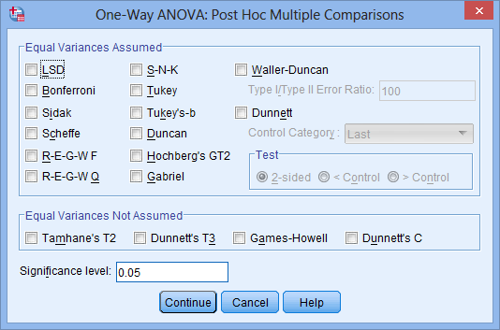6. Click the https://statistics.laerd.com/premium/owa/img/post-hoc-button.pngbutton and you will be presented with the **One-Way ANOVA: Post Hoc Multiple Comparisons** dialogue box, as shown below:

Note: There are many other options you could select other than Tukey. The LSD option means "least significant difference" and it is basically multiple independent-samples t-tests between each combination of groups without any corrections made for multiple comparisons. A popular option is Bonferroni, which is multiple independent-samples t-tests, as with "LSD", but with a Bonferroni correction for multiple comparisons.

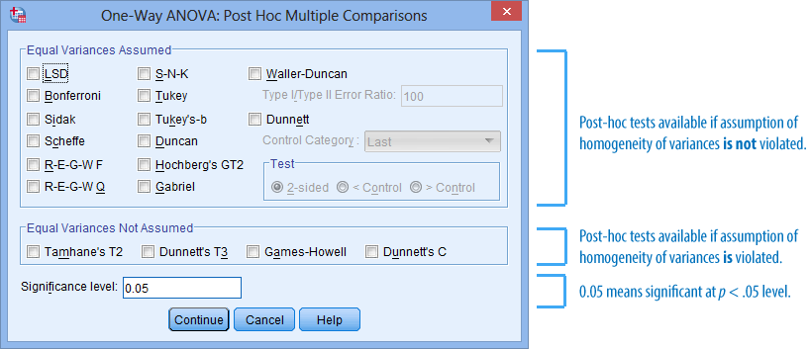

7. Click Tukey in the –Equal Variances Assumed– area and Games-Howell in the –Equal Variances Not Assumed– area, as shown below:

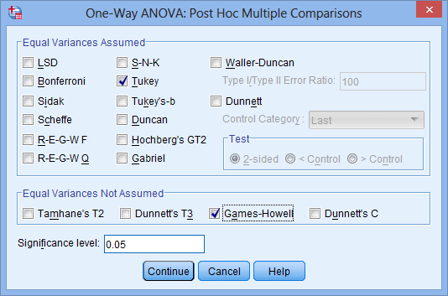

8. If you wish, you can change the significance level to another value (e.g., 0.01) in the Significance level: box. For this example, keep the significance level at the default 0.05 (i.e., statistical significance declared when p < .05).

9. Click the https://statistics.laerd.com/premium/owa/img/continue-button.pngbutton and you will be returned to the **One-Way ANOVA** dialogue box.

10. Click the https://statistics.laerd.com/premium/owa/img/ok-button.pngbutton. This will generate the output.

Homogeneity of Variances

At this stage of the analysis you will have analyzed your data for outliers and normality, but not yet interpreted whether the third major assumption – homogeneity of variances – is violated or not. If the variances are unequal, this can affect the Type I error rate. In this example, the (population) variance for CWWS scores, stress_coping, for all levels of group should be equal. If this is not the case, corrections can be applied to the calculations of the one-way ANOVA so that any violation of homogeneity of variances can be compensated for and the test remains valid. The assumption of homogeneity of variances is tested for using Levene's Test of Equality of Variances, which is found in the **Test of Homogeneity of Variances** table, as shown below:

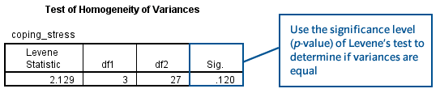

If Levene's test is statistically significant (i.e., p < .05), you do not have equal variances and have violated the assumption of homogeneity of variances (i.e., you have heterogeneous variances). On the other hand, if Levene's test is not statistically significant (i.e., p > .05), you have equal variances and you have not violated the assumption of homogeneity of variances.

One Way ANOVA

The results of the one-way ANOVA are found in the **ANOVA** table, as shown below:

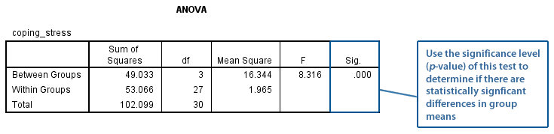

If the ANOVA is statistically significant (i.e., p < .05), it can be concluded that not all group means are equal in the population (i.e., at least one group mean is different to another group mean). The significance level (p-value) is found in the "**Sig.**" column as highlighted in the table above. Alternatively, if p > .05, you do not have any statistically significant differences between the group means. The p-value in this example would appear to be .000 (obtained from the "**Sig.**" column). However, if you ever see SPSS print out a p-value of .000, do not interpret this as a significance level that is actually zero; it actually means p < .0005. As p < .05 in this example (p < .0005 is less than p < .05), it can be concluded that there is a statistically significant difference in coping_stress scores for the different levels of group, F(3,27) = 8.316, p < .001.

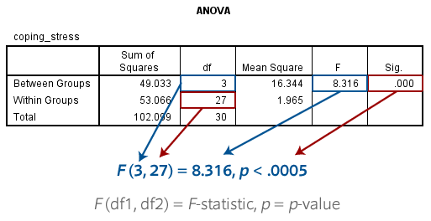

With the meaning of each part as follows:

|  |  |
| --- | --- |
| **Part** | **Meaning** |
| *F* | Indicates that you are comparing to an *F*-distribution (*F*-test). |
| 3 in (3,27) | Indicates the Between Groups degrees of freedom ("df1") |
| 27 in (3,27) | Indicates the Within Groups [Error] degrees of freedom ("df2") |
| 8.316 | Indicates the obtained value of the *F*-statistic (obtained *F*-value) |
| *p* < .001 | Indicates the probability of obtaining the observed *F*-value if the null hypothesis is correct. |

## Tukey post-hoc test

The Tukey post-hoc test is a good test if you wish to compare all possible combinations of group differences when the assumption of homogeneity of variances is not violated. As well as showing whether any differences between groups are statistically significant, this post-hoc test also provides confidence intervals for the differences between the group means. The Tukey post-hoc test results are presented in the **Multiple Comparisons** table, as shown below:

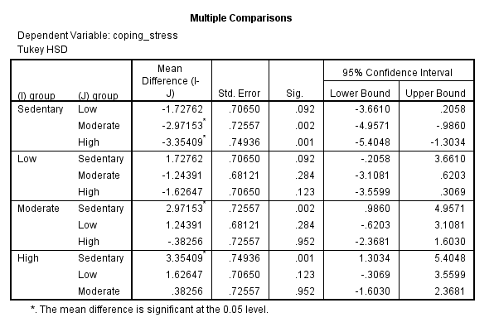

With four groups there will be six possible combinations of group differences, but in the table above, there are twelve combinations. This is because the data is repeated twice for each group combination (e.g., Group A vs. Group B and then the reverse, Group B vs. Group A). You can, therefore, remove the duplicates in the table to leave only the six unique combinations, as has been done below:

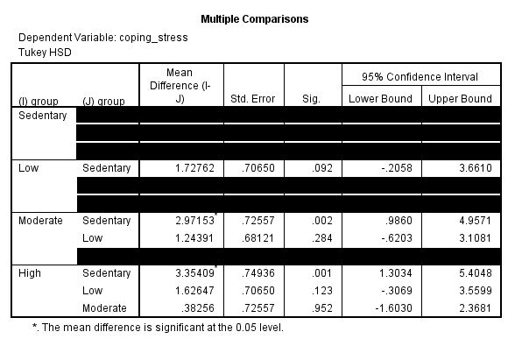

The information in each column in the above table has the following meaning:

|  |  |
| --- | --- |
| **Column Name** | **Column Meaning** |
| Mean Difference (I - J) | Mean difference between group I and group J (I minus J) |
| Std. Error | Standard error of the difference between group I and J |
| Sig. | Significance level (*p*-value) of the difference between group I and J |
| Lower Bound | The lower bound (limit) of the 95% confidence interval for the difference between group I and J |
| Upper Bound | The upper bound (limit) of the 95% confidence interval for the difference between group I and J |

Each row can be interpreted separately. For example, consider the following comparison highlighted below: 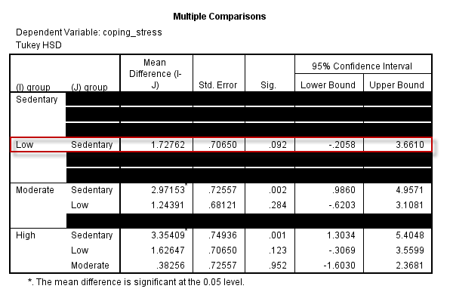

As the "**Sig.**" value (p-value) is greater than .05 (it is p = .092), the difference between these two groups is not statistically significant (i.e., their group population means are equal). You can now work through each comparison in turn and report the result. Alternatively, you can report the results in a table or graph.

## Calculating and reporting effect size

There is more than one method of calculating an effect size for a one-way ANOVA. The preferred method is an effect size measure called omega squared (ω2). This is calculated as:

https://statistics.laerd.com/premium/owa/img/omega-squared-1.png

To make these calculations you need to utilize the **ANOVA** table, as follows:

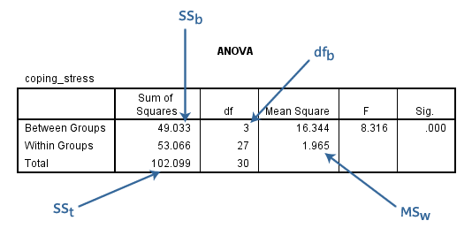

https://statistics.laerd.com/premium/owa/img/omega-squared-2.png

Therefore, there is an effect size ω2 = .42. You should report this will the result of the one-way ANOVA.

Bar Chart in SPSS

A bar chart can be used to visually present the results of many types of statistical test or data on its own. The following instructions show you how to produce a bar chart in SPSS:

1. Click **Graphs > Chart Builder...** on the main menu, as shown below:

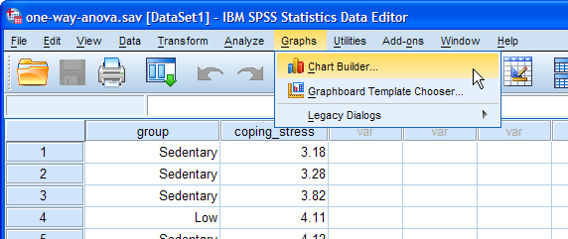

2. Select "Bar" from the Choose from: box in the bottom-left-hand corner of the **Chart Builder** dialogue box, as highlighted below:

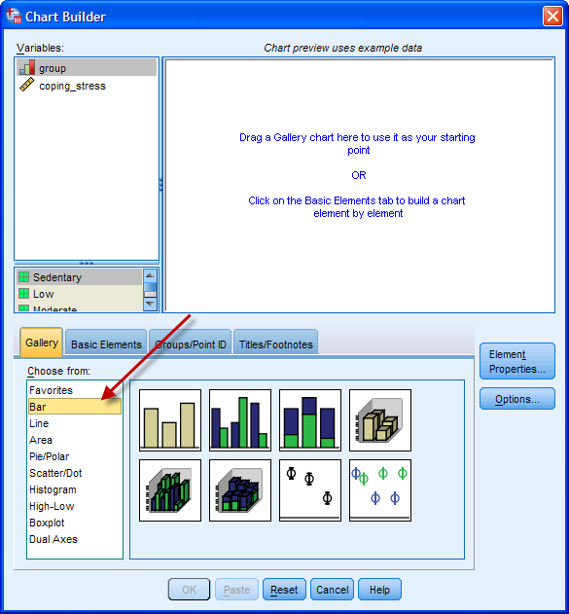

3. Selecting "Bar" will present eight different bar chart options in the lower-middle section of the **Chart Builder** dialogue box (as shown above and below). Drag-and-drop the top-left-hand option (you will see it labeled as "Simple Bar" if you hover your mouse over the box) into the main chart preview pane, as shown below:

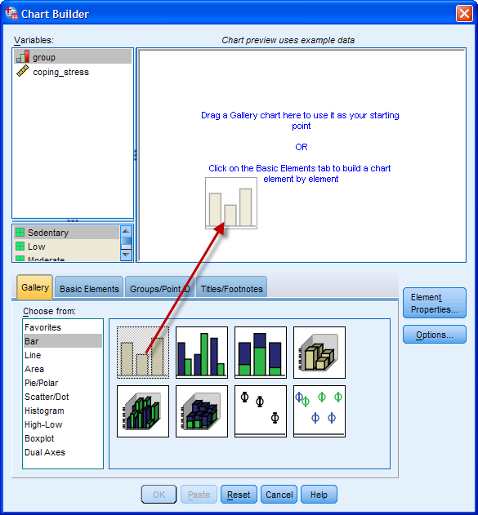

4. Drag-and-drop the independent variable, group, from the Variables: box into the "X-axis?" box in the main chart preview screen and do the same for the dependent variable, coping_stress, but into the "Y-axis?" box. You should end up with a screen like below:

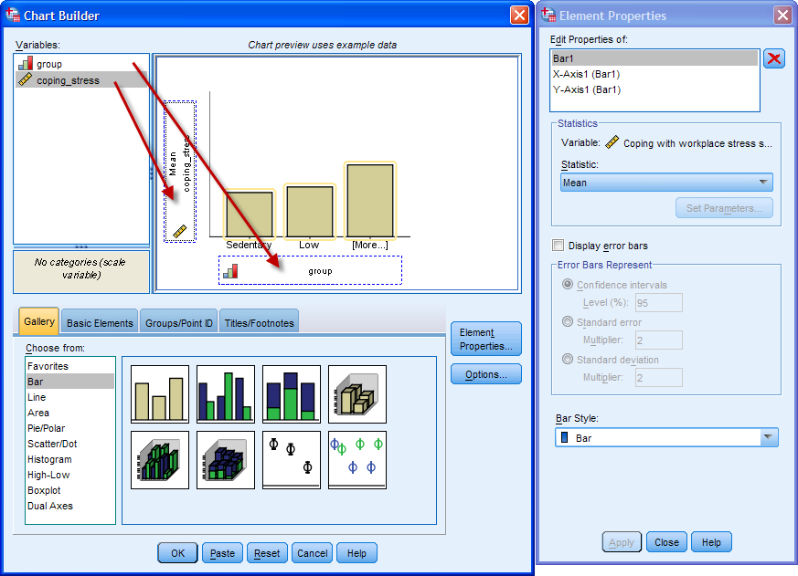

Note: The chart preview pane does not accurately plot the variable data that you have dragged into the preview pane, even though it might appear that it does due to the bar chart's bars changing when you add your variables. Therefore, do not get confused and think that you have done something wrong. You will only see your true data when you actually generate the bar chart.

5. Click Display error bars in the **Element Properties** dialogue box, which will activate the -Error Bars Represent- area. Leave Confidence intervals selected and Level (%): set at 95. You will be presented with the following screen:

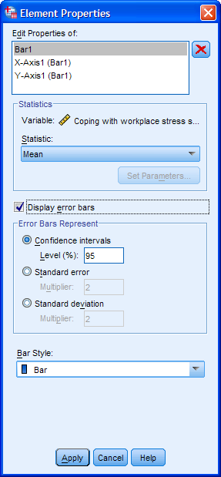

6. Click the https://statistics.laerd.com/premium/bc/img/apply-button.pngbutton to confirm these changes.

7. If you want to change the order of the categories of the independent variable, click "X-Axis1 (Bar1)" in the "Edit Properties of: box and make these changes. In this example, everything is OK as it is.

8. If you want to change the scale of the y-axis (for the dependent variable), click "Y-Axis1 (Bar1)" in the "Edit Properties of: box and make these changes. In this example, everything is OK as it is.

9. Click the https://statistics.laerd.com/premium/bc/img/ok-button.pngbutton in the **Chart Builder** dialogue box to generate the bar chart.

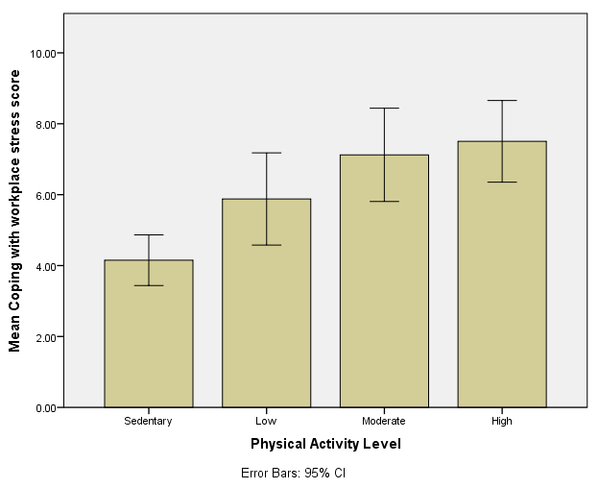 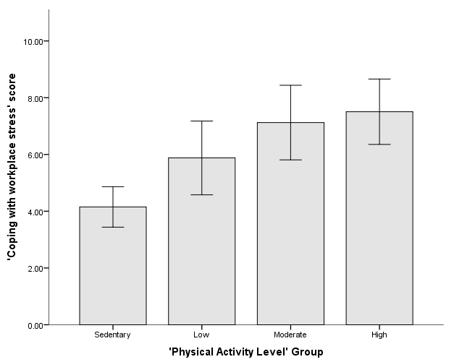

Using SPSS's chart editing tools, you can spruce this chart up to look like the following (and more appropriate for a report).

Reporting

A one-way ANOVA was conducted to determine if the ability to cope with workplace-related stress (CWWS score) was different for groups with different physical activity levels. Participants were classified into four groups: sedentary (n = 7), low (n = 9), moderate (n = 8) and high levels of physical activity (n = 7). There were no outliers, as assessed by boxplot; data was normally distributed for each group, as assessed by Shapiro-Wilk test (p > .05); and there was homogeneity of variances, as assessed by Levene's test of homogeneity of variances (p > .05). Data is presented as mean ± standard deviation. CWWS score was statistically significantly different between different physical activity groups, F(3, 27) = 8.316, p < .001, ω2 = 0.42. CWWS score increased from the sedentary (M = 4.15, SD = 0.77) to the low (M = 5.88, SD = 1.69), moderate (M = 7.12, SD = 1.57) and high (M = 7.51, SD = 1.24) physical activity groups, in that order. Tukey post hoc analysis revealed that the mean increase from sedentary to moderate (2.97, 95% CI [0.99, 4.96]) was statistically significant (p < .01), as well as the increase from sedentary to high (3.35, 95% CI [1.30, 5.40], p < .001), but no other group differences were statistically significant.